Министерство образования Новосибирской области ГБПОУ НСО «Новосибирский авиационный технический колледж имени Б.С.Галущака»

СРС № 2

Тема: понятие о моделях и моделировании

Учебная дисциплина: МДК.02.03 Математическое моделирование

Работу выполнил:

студент группы ПР-21.102:

Ядыкин С. И.

Проверил: Оболенцева Т. Д.

2023

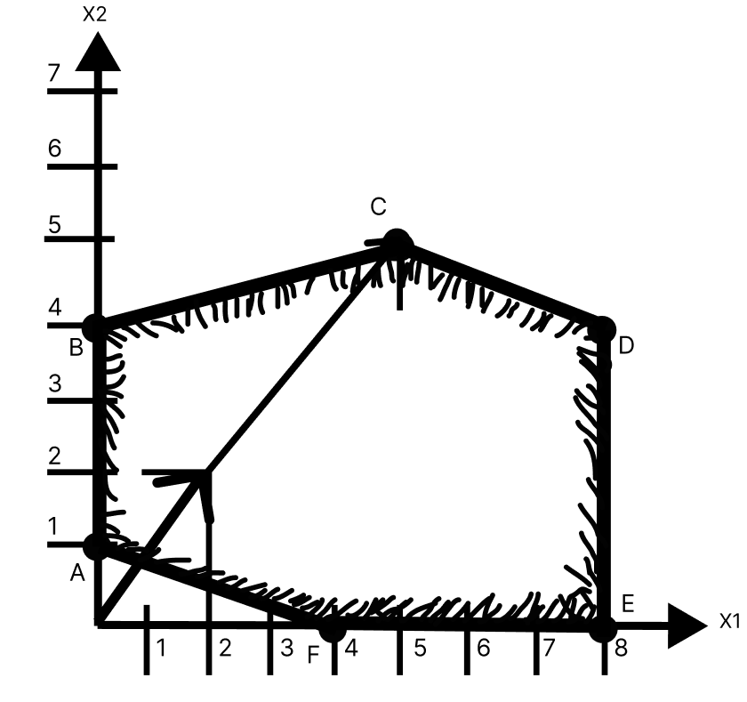Графическое решение задачи ЛП

Известные точки

**A** (0;1), **B** (0;4), **C** (5;5), **D** (8;4), **E** (8;0), **F** (4;0)

**Уравнения прямых**

AB: x1>=0

BC: x1+5*x2 <=30

CD: x1<=8

DE: x1<=8

EF: x2>=0

FA: 4x1+x2>=4

Ñ = (k*C1, k*C2) при k = 1, C1 = 2, С2 = 2

**Ƶ = 2*x1 + 2*x2 = min(max)**

**Математическая модель**

x1+5*x2 <=30

2*x1+x2<=20

x1<=8

x1 + 4*x2 >= 4

Проведём перпендикуляры относительно нормали и точек многоугольника решений

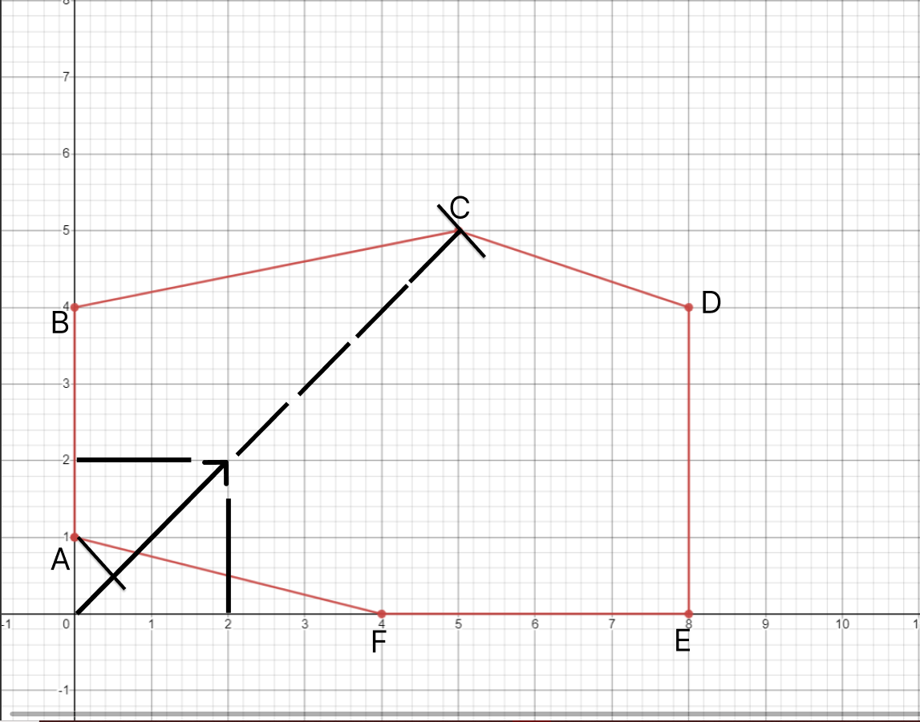

Таким образом мы видим, что min находиться в точке А с координатами x1=0, x2=1, а max в точке D, с координатами x1=6, x2=6.

Ƶ = 2*x1 + 2*x2 = min(max)

**Ƶ(min) = 2*0+2*1 = 2 А**

Ƶ(max) = 8*2+2*4 = 24 D

**Решение задачи ЛП симплекс методом**

x1+5*x2 <=30

2*x1+x2<=20

x1<=8

x1 + 4*x2 >= 4

C1 = 2

C2 = 2

Свободные переменные x3, x4, x5, x6

Искусственные переменные x7, x8, x9, x10

Ƶ = 2*x1 + 2*x2 + 0*x3 + 0*x4 + 0*x5 + 0*x6 + M*x7 + M*x8 + M*x9 ⇒min(max)

x1+5*x2+x3+0*x4+0*x5+0*x6+x7+0*x8+0*x9+0*x10=30

2*x1+x2+0*x3+x4+0*x5+0*x6+0*x7+x8+0*x9+0*x10=20

x1+0*x2+0*x3+0*x4+x5+0*x6+0*x7+0*x8+x9+0*x10=8

2*x1+5*x2-0*x3-0*x4-0*x5-x6-0*x7-0*x8-0*x9-x10=4

**Находим max**

|  |  |  |  |  |  |  |  |  |  |  |  |  |  |  |
| --- | --- | --- | --- | --- | --- | --- | --- | --- | --- | --- | --- | --- | --- | --- |
| План 1 | | | | | | | | | | | | | | |
| **С =** | | | | **2** | **2** | **0** | **0** | **0** | **0** | **М** | **М** | **М** | **М** |
| **N** | **Базис** | **с Базис** | **А0** | **А1** | **А2** | **А3** | **А4** | **А5** | **А6** | **А7** | **А8** | **А9** | **А10** |
| **1** | **А7** | **М** | **30** | 1 | 5 | 1 | 0 | 0 | 0 | 1 | 0 | 0 | 0 |
| **2** | **А8** | **М** | **20** | 2 | 1 | 0 | 1 | 0 | 0 | 0 | 1 | 0 | 0 |
| **3** | **А9** | **М** | **8** | 1 | 0 | 0 | 0 | 1 | 0 | 0 | 0 | 1 | 0 |
| **4** | **А10** | **М** | **5** | 1 | 4 | 0 | 0 | 0 | -1 | 0 | 0 | 0 | 0 |
| **м+1** | **zj-ij** | - | 63М | 5М-2 | 10М-2 | М | М | М | -М | 0 | 0 | 0 | -2М |

Min = (30/5, 20/1, 8/0, 5/4) = 2

|  |  |  |  |  |  |  |  |  |  |  |  |  |  |
| --- | --- | --- | --- | --- | --- | --- | --- | --- | --- | --- | --- | --- | --- |
| План 2 | | | | | | | | | | | | | |
| **С =** | | |  | **2** | **2** | **0** | **0** | **0** | **0** | **М** | **М** | **М** | **М** |
| **N** | **Базис** | **с Базис** | **А0** | **А1** | **А2** | **А3** | **А4** | **А5** | **А6** | **А7** | **А8** | **А9** | **А10** |
| **1** | **А7** | **М** | **23.75** | -0.25 | 0 | 1 | 0 | 0 | 1.25 | 1 | 0 | 0 | 1.25 |
| **2** | **А8** | **М** | **18.75** | 1.75 | 0 | 0 | 1 | 0 | 0.25 | 0 | 1 | 0 | 0,25 |
| **3** | **А9** | **М** | **8** | 1 | 0 | 0 | 0 | 1 | 0 | 0 | 0 | 1 | 0 |
| **4** | **А2** | **2** | **1.25** | 0.25 | 1 | 0 | 0 | 0 | -0.25 | 0 | 0 | 0 | -0,25 |
| **м+1** | **zj-ij** | - | **51,75М** | 2,5М-1,5 | 0 | М | М | М | 1,5М-0.5 | 0 | 0 | 0 | 0,5М-0,5 |

Min = (23,75/-0,25, 18,75/1,75, 8/1, 1,25/0.25) = 5

Данный план соответствует точке А.

|  |  |  |  |  |  |  |  |  |  |  |  |  |  |
| --- | --- | --- | --- | --- | --- | --- | --- | --- | --- | --- | --- | --- | --- |
| План 3 | | | | | | | | | | | | | |
| **С =** | | |  | **2** | **2** | **0** | **0** | **0** | **0** | **М** | **М** | **М** | **М** |
| **N** | **Базис** | **с Базис** | **А0** | **А1** | **А2** | **А3** | **А4** | **А5** | **А6** | **А7** | **А8** | **А9** | **А10** |
| **1** | **А7** | **М** | **25** | 0 | 1 | 1 | 0 | 0 | 1 | 1 | 0 | 0 | 1 |
| **2** | **А8** | **М** | **10** | 0 | -7 | 0 | 1 | 0 | 2 | 0 | 1 | 0 | 2 |
| **3** | **А9** | **М** | **3** | 0 | -4 | 0 | 0 | 1 | 1 | 0 | 0 | 1 | 1 |
| **4** | **А1** | **2** | **5** | 1 | 4 | 0 | 0 | 0 | -1 | 0 | 0 | 0 | -1 |
| **м+1** | **zj-ij** | - | **37М+5** | 0 | -10М  +4 | М | М | М | 4М-2 | 0 | 0 | 0 | -2 |

Min = (25/1, 10/2, 3/1, 5/-1) = 3

Данный план соответствует точке F.

|  |  |  |  |  |  |  |  |  |  |  |  |  |  |  |
| --- | --- | --- | --- | --- | --- | --- | --- | --- | --- | --- | --- | --- | --- | --- |
| План 4 | | | | | | | | | | | | | | |
| **С =** | | |  | **2** | **2** | **0** | **0** | **0** | **0** | **М** | **М** | **М** | **М** |
| **N** | **Базис** | **с Базис** | **А0** | **А1** | **А2** | **А3** | **А4** | **А5** | **А6** | **А7** | **А8** | **А9** | **А10** |
| **1** | **А7** | **М** | **22** | **0** | **5** | **1** | **0** | **-1** | **0** | **1** | **0** | **-1** | 0 |
| **2** | **А8** | **М** | **4** | **0** | **1** | **0** | **1** | **-2** | **0** | **0** | **1** | **-2** | 0 |
| **3** | **А6** | **0** | **3** | **0** | **-4** | **0** | **0** | **1** | **1** | **0** | **0** | **1** | 1 |
| **4** | **А1** | **2** | **8** | **1** | **0** | **0** | **0** | **1** | **0** | **0** | **0** | **1** | 0 |
| **м+1** | **zj-ij** | - | **37М+8** | **3М** | **6М-2** | **М** | **М** | **-3М+4** | **0** | **0** | **0** | **-4М+4** | -М |

Min = (24/5, 3/1, 2/-5, 6/0) = 4

Данный план соответствует точке E.

|  |  |  |  |  |  |  |  |  |  |  |  |  |  |  |  |  |  |  |  |  |  |  |  |  |  |  |
| --- | --- | --- | --- | --- | --- | --- | --- | --- | --- | --- | --- | --- | --- | --- | --- | --- | --- | --- | --- | --- | --- | --- | --- | --- | --- | --- |
| План 5 | | | | | | | | | | | | | | | | | | | | | | | | | | |
| **С =** | | | |  | | **2** | | **2** | | **0** | | **0** | | **0** | | **0** | | **М** | | **М** | | **М** | | **М** | |
| **N** | **Базис** | **с Базис** | **А0** | | **А1** | | **А2** | | **А3** | | **А4** | | **А5** | | **А6** | | **А7** | | **А8** | | **А9** | | **А10** | |
| **1** | **А7** | **М** | **2** | | **0** | | **0** | | **1** | | **-5** | | **9** | | **0** | | **1** | | **-5** | | **9** | | **0** | |
| **2** | **А2** | **2** | **4** | | **0** | | **1** | | **0** | | **1** | | **-2** | | **0** | | **0** | | **1** | | **-2** | | **0** | |
| **3** | **А6** | **0** | **19** | | **0** | | **0** | | **0** | | **4** | | **-7** | | **1** | | **0** | | **4** | | **-7** | | **1** | |
| **4** | **А1** | **2** | **8** | | **1** | | **0** | | **0** | | **0** | | **1** | | **0** | | **0** | | **0** | | **1** | | **0** | |
| **м+1** | **zj-ij** | - | **2М+31** | | **0** | | **0** | | **М** | | **-5М+2** | | **9М-2** | | **0** | | **0** | | **-6М+2** | | **8М-2** | | **0** | |

Min = (2/9, 4/-2, 19/-7, 8/1) =  0.22

Данный план соответствует точке D.

|  |  |  |  |  |  |  |  |  |  |  |  |  |  |
| --- | --- | --- | --- | --- | --- | --- | --- | --- | --- | --- | --- | --- | --- |
| План 6 | | | | | | | | | | | | | |
| **С =** | | |  | **2** | **2** | **0** | **0** | **0** | **0** | **М** | **М** | **М** | **М** |
| **N** | **Базис** | **с Базис** | **А0** | **А1** | **А2** | **А3** | **А4** | **А5** | **А6** | **А7** | **А8** | **А9** | **А10** |
| **1** | **А5** | **0** | **0.22** | 0 | 0 | 0,11 | -0,56 | 1 | 0 | 0,11 | -0,56 | 1 | 0 |
| **2** | **А2** | **2** | **4.44** | 0 | 1 | 0,22 | -0,11 | 0 | 0 | 0,22 | -0,11 | 0 | 0 |
| **3** | **А6** | **0** | **20.56** | 0 | 0 | 0,78 | 0,11 | 0 | 1 | 0,89 | 0,11 | 0 | 1 |
| **4** | **А1** | **2** | **7.78** | 1 | 0 | -0,11 | 0,56 | 0 | 0 | -0,11 | 0,56 | 0 | 0 |
| **м+1** | **zj-ij** |  | **24,44** | 0 | 0 | 0,22 | 0,89 | 0 | 0 | 0,22 | 0,89 | 0 | 0 |

Данный план соответствует точке D.

Вывод план 6 соответствует точке D. В m+1 последней таблицы оценки больше или равны 0 план оптимален, z(max) = 24,44. (x1=8; x2=4)

**Вывод**

Таким образом мы научились решать задачи линейного программирования при помощи 2 методов (Графический, симплекс метод).